[Preprocessing digital breast mammograms using adaptive weighted frost filter](http://www.biomedres.info/biomedical-research/preprocessing-digital-breast-mammograms-using-adaptive-weighted-frost-filter.html)

**Muhammad Talha**[**1**](http://www.biomedres.info/biomedical-research/preprocessing-digital-breast-mammograms-using-adaptive-weighted-frost-filter.html#a1)[**\***](http://www.biomedres.info/biomedical-research/preprocessing-digital-breast-mammograms-using-adaptive-weighted-frost-filter.html#corr)**, Ghazali Bin Sulong**[**2**](http://www.biomedres.info/biomedical-research/preprocessing-digital-breast-mammograms-using-adaptive-weighted-frost-filter.html#a2)**, Arfan Jaffar**[**3**](http://www.biomedres.info/biomedical-research/preprocessing-digital-breast-mammograms-using-adaptive-weighted-frost-filter.html#a3)

1Deanship of Scientific Research, King Saud University Riyadh Saudi Arabia

2Faculty of Computing, Universiti Teknologi Malaysia

3Department of Computer Science, Imam Muhammad Bin Saud Islamic University, Saudi Arabia

**Abstract**

Many techniques have been used to enhance image quality, image smoothing and noise restoration. The experimental results conclude that the proposed **Adaptive Weighted Frost filter i**s the best suitable choice for eliminating noise from mammographic images and performs better comparatively. The comparison of proposed technique with various existing techniques is performed both qualitatively and quantitatively. The experiments have demonstrated that the proposed technique provides better results as compare to existing techniques.

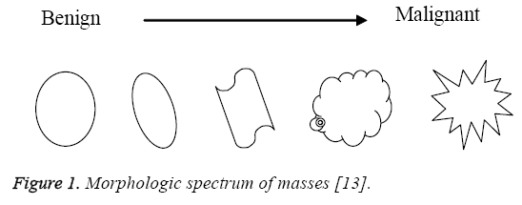

Sometimes it becomes quiet complicated to distinguish between benign and malignant masses because of low-contrast. So it is pertinent to apply any automatic technique to enhance the visual quality of mammographic image in order to forefront the malignancies, if exists. **Enhancing the contrast, extracting the features and removing the noise are the fundamental issues in mammograms which need to be addressed** [[14](http://www.biomedres.info/biomedical-research/preprocessing-digital-breast-mammograms-using-adaptive-weighted-frost-filter.html#14)]. Noise may be expressed as any change in the mammogram that do not relate to variations in the X-ray attenuation of the object being imaged. X-ray quantum noise is the significant type of no**ise which is denoted by a Poisson distribution** [[15](http://www.biomedres.info/biomedical-research/preprocessing-digital-breast-mammograms-using-adaptive-weighted-frost-filter.html#15)]. Such type of noise is generally introduced during mammograms image acquisition because of less number of x-ray photons. It reduces the contrast of the mammogram image mainly which results in the **low value of signal-to-noise ratio** (SNR) [[16](http://www.biomedres.info/biomedical-research/preprocessing-digital-breast-mammograms-using-adaptive-weighted-frost-filter.html#16)]. Resultantly, the contrast of mammogram**s becomes low because of quantum noise whose detection is not only a complicated job but also challenging for the radiologists. False-negatives for radiologist mammography interpretation vary from 10 to 30% due to different factors** [[17](http://www.biomedres.info/biomedical-research/preprocessing-digital-breast-mammograms-using-adaptive-weighted-frost-filter.html#17)].

Some existing methods on image enhancement are **median filtering, Frost filter, Wiener filter, histogram equalization and contrast limited adaptive histogram equalization.** The radiologist uses various softwares like **“ImageChecker” and “SecondLook”** to enhance and/or zoom the selected part of the mammograms which are usually based on various enhancement, segmentation/cropping and zooming techniques. For the enhancement of mammograms, Bhateja et al. [[18](http://www.biomedres.info/biomedical-research/preprocessing-digital-breast-mammograms-using-adaptive-weighted-frost-filter.html#18)] used median filter to suppress salt and pepper noise. For noise restoration, the average of three filters (**Frost, Adaptive Wiener and non-local mean)** was proposed by Naveed et al. [[19](http://www.biomedres.info/biomedical-research/preprocessing-digital-breast-mammograms-using-adaptive-weighted-frost-filter.html#19)]. The mean value of these filters was replaced with noisy pixels. The authors implemented their technique on salt & pepper and quantum noise. They used **PSNR and SSIM** (structural similarity index measure) as performance measures to evaluate the performance of the proposed technique with various existing methods in literature. Numerous computer aided techniques for image processing have been developed and applied by many of researchers for the enhancement of mammographic images using various filters. In our proposed method, the **Frost filter is modified which intelligently remove the noise from the mammograms.**

**Materials and Methods**

**Adaptive weighted frost filter for quantum noise removal**

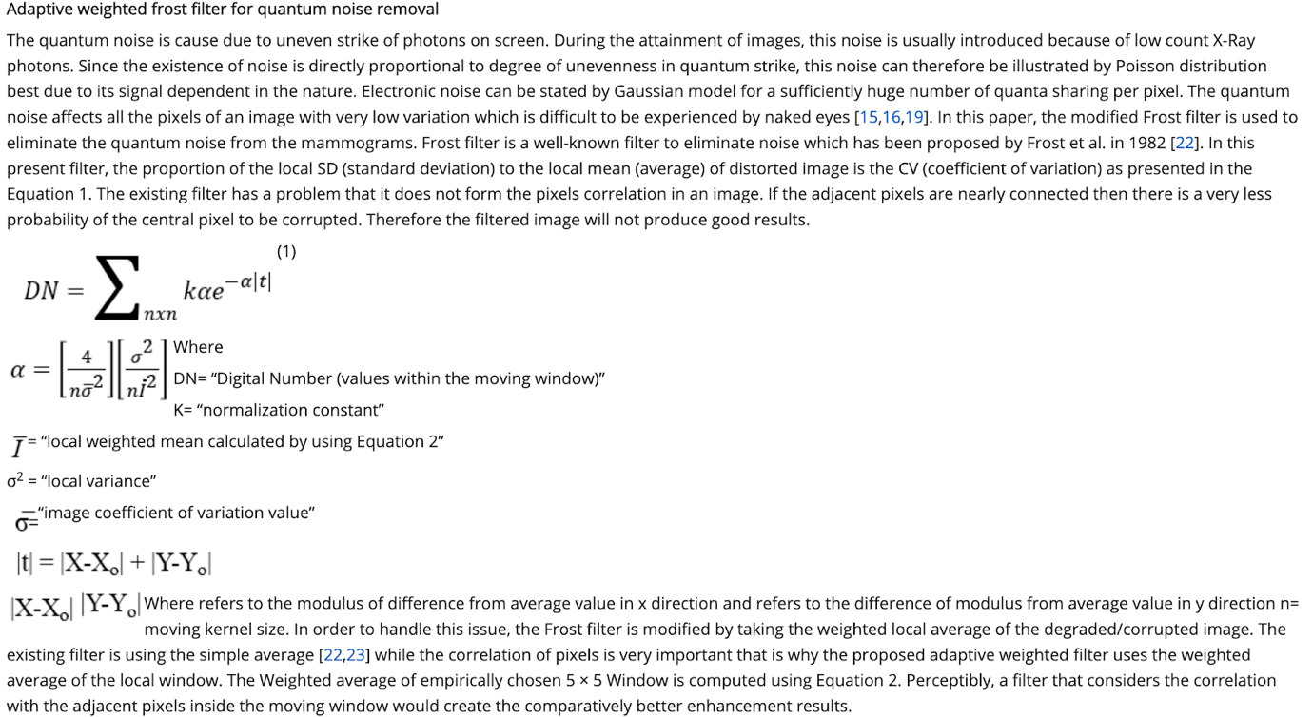

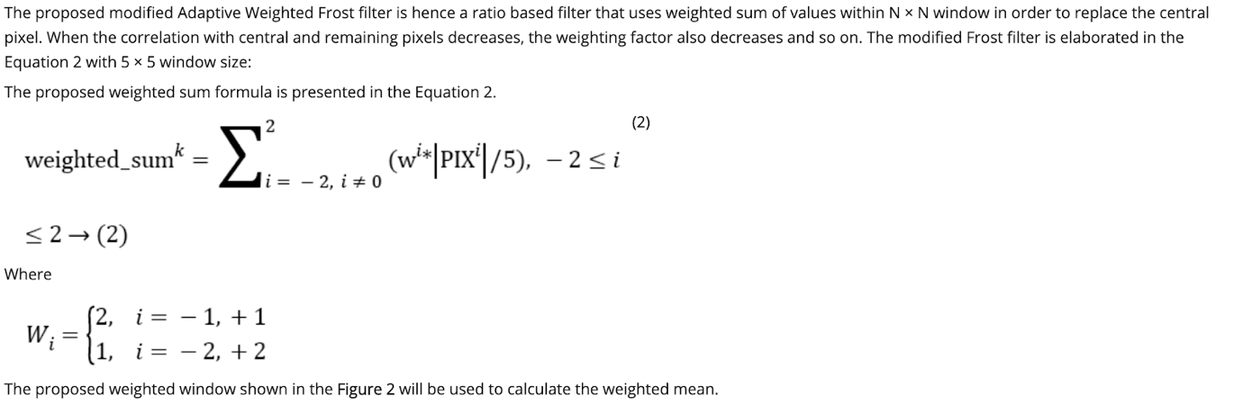

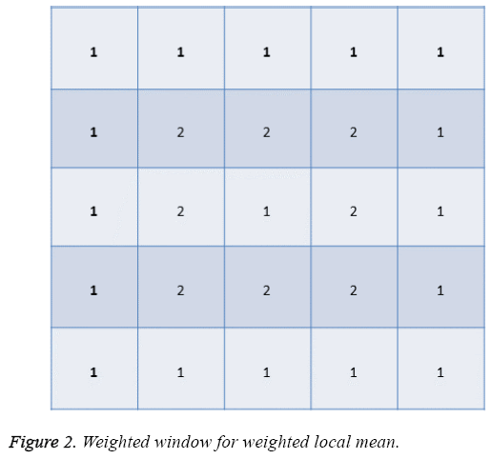

If the **lag distance of two pixels is less, then usually the gray scale values are closer to each other. So accordingly as presented in Figure 2, more weight is assigned to the pixels whose lag distance is 1 and less weight whose lag distance is 2 to create the correlation among adjacent pixels.** Thus the **high correlation of connected pixels is achieved which is very important here since the adjacent pixels contribute well in order to restore the central pixel of degraded image.** Consequently, the resultant pixel value has been replaced by the weighted mean of filter window. That is why the proposed **Adaptive Weighted Frost filter is better to the existing Frost and Wiener filter for quantum noise removal from mammograms.**

**Performance measure**

Peak signal-to-noise ratio (PSNR) is taken as a quantitative measurement in order to evaluate the performance of the proposed Adaptive Weighted Frost filter to remove the quantum from mammograms using the Equation 3 [[19](http://www.biomedres.info/biomedical-research/preprocessing-digital-breast-mammograms-using-adaptive-weighted-frost-filter.html#19)]. The PSNR value ranges from 30 to 50 db is considered acceptable which means that the visual quality of mammogram is improved.

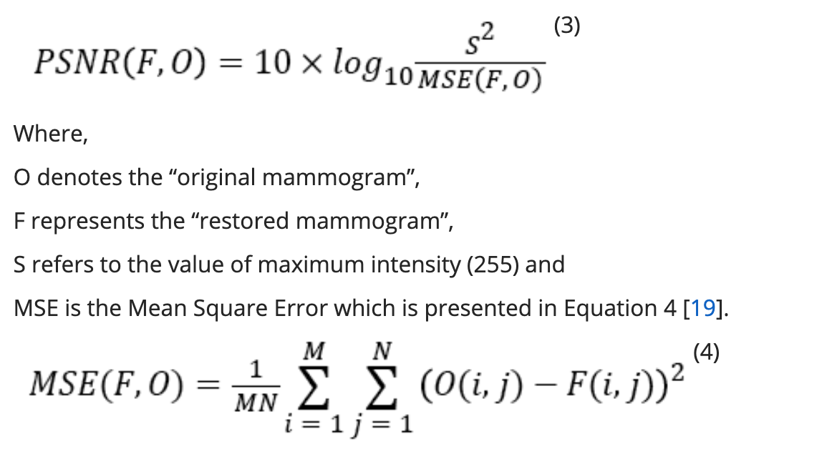

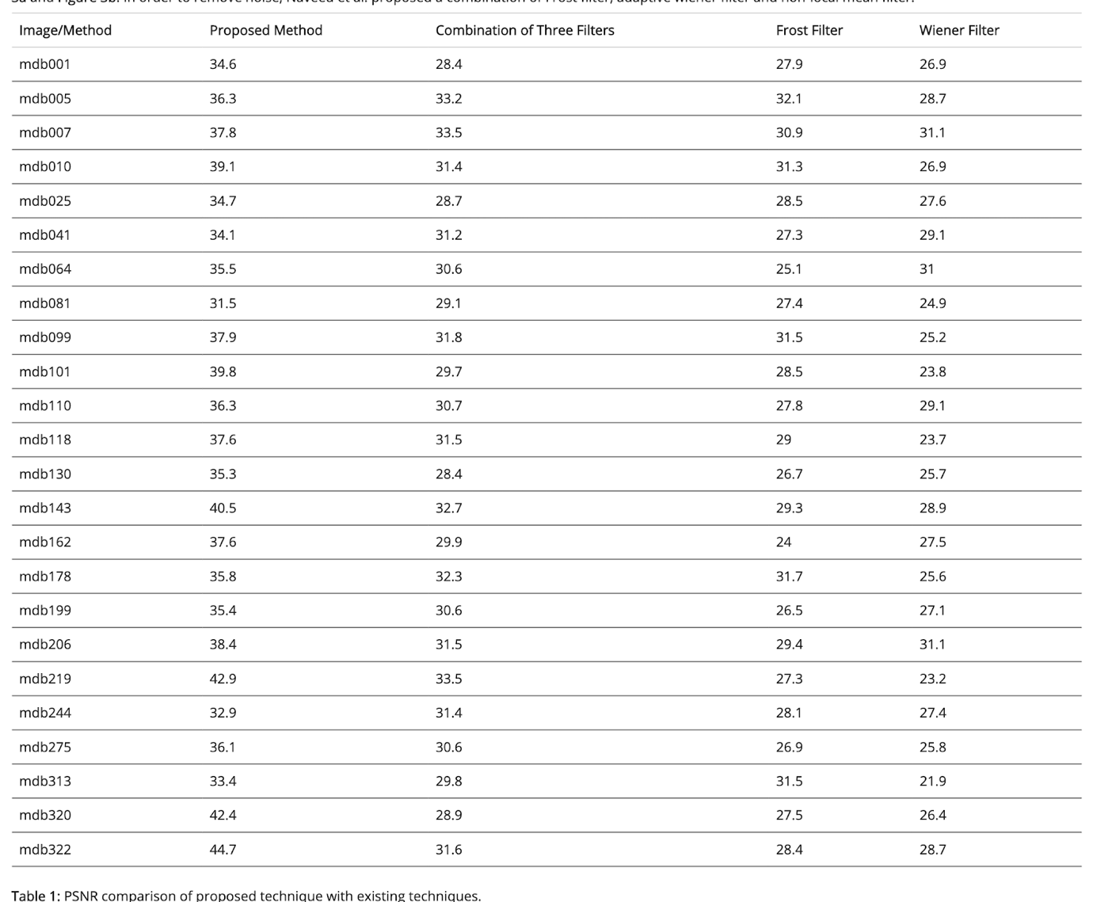

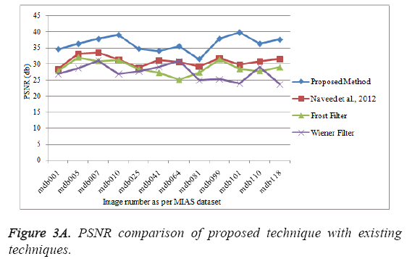

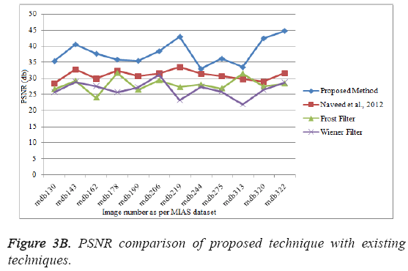

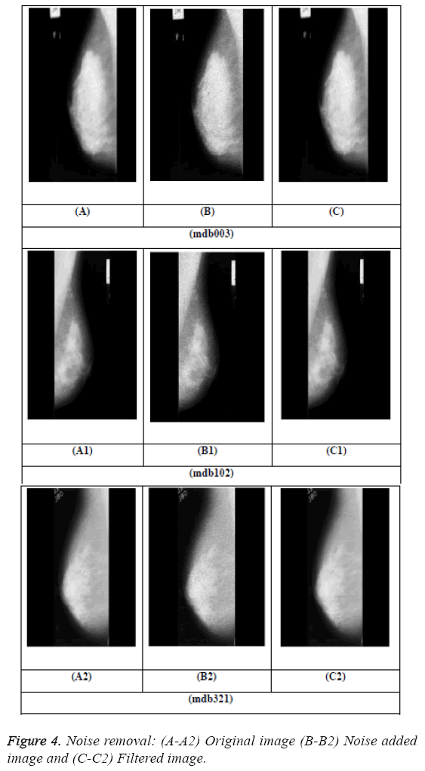**Conclusion**

     The presented noise restoration technique by using modified **Frost filter to improve the quality of mammographic images showed promising results.** The results demonstrated that the restored mammograms showed low noise level (**high PSNR**) and better spatial resolution (resemblance to their originals and no artifacts are produced in mammogram images). The preprocessed mammographic images showed better qualitative and quantitative results which are helpful for further processing such as features extraction, micro-calcification detection, breast cancer diagnosis, classification, etc. The proper preprocessing steps also increase the efficiency of CAD (computer aided diagnosis) systems which are used by radiologists for abnormalities detection. The modified Frost filter produced better PSNR values, for example in mdb001, the PSNR values produced by modified Frost filter is 34.6 db, Naveed et al. is **28.4 db, Frost filter 27.9 db and Wiener filter is 26.9 db.** The same trend is shown by all mammographic images which illustrates the supremacy of proposed modified filter for mammograms restoration